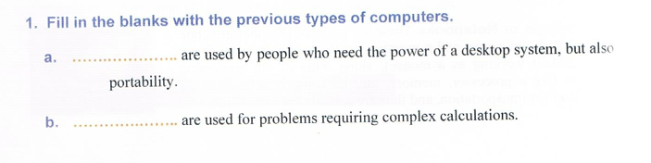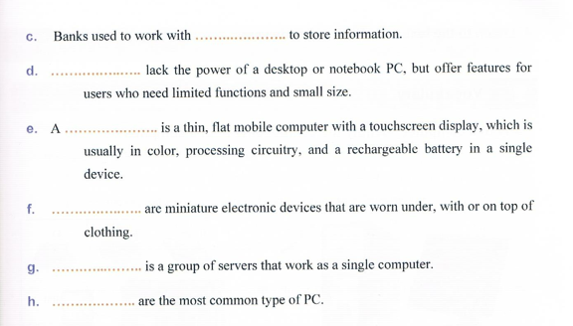

1. Laptops
2. Supercomputers
3. Mainframe
4. Netbook
5. Tablet
6. Wearable computers
7. Clusters
8. Desktop computers

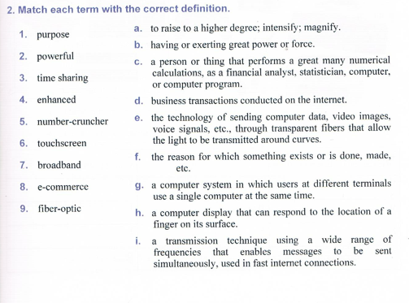

1. f
2. b
3. g
4. a
5. c
6. h
7. i
8. d
9. e